# 

# METHOD OF CONSTRUCTION

#### Client :

#### Firm Design :

#### Architect & Engineering :

**METHODS OF CONSTRUCTION INCLUDING**

**TESTING & COMMISSIONING**

Contents

* **Preface……………………………………………………………………………………………………3**
* **Project Overview ……………………………………………...……………………………………….3**
* **General Description of the project………………………………………………………………….4**
* **Building Configuration………………………………………………………………………….…….5**
* **MEP Scope of work……………………………….……………………………………………………6**
* **Mobilization……………………………………………………………………………………………...6**
* **Overview Program of Work…………………………………………………………………..………7**
* **Program- Basis & Assumptions……………………………………………………………………..7**
* **Main Critical Path………………………………………………………………………………………9**
* **Sequence of Construction…………………………………………………………………………10**
* **Main Requirements from Employer/ Main Contractor………………………………………….11**
* **Project Execution…………………………………………………………………………………..…15**
* **Authority Approval……………………………………………………………………………………17**
* **Commissioning………………………………………………………………………………………..18**
* **Closeout & Hand over………………………………………………………………………………..18**

* **Preface**

This Method statement will provide our overview of the Construction Sequences & Programme exercise that has been undertaken at Tender Stage and will form the basis of more detailed Method Statements for specific portions of the work during execution.

* **Project overview**

The Mashreq Bank Headquarters Building is an office use development located on parcel No. 3450782 in the Burj Khalifa Development, Dubai. The project consists of a 150 meter tall office tower with 31 levels, containing a branch bank space and café located on ground level, conference and dining amenities and executive office functions on the top levels.

Total above grade area is approximately 56,000 square meters. The tower will contain approximately 32,500 sqm of office space.

The ground floor lobby links the drop-off area and parking shuttle elevators to the building core and two zones of elevators banks. The Mashreq Branch Banking Hall is accessed through both the main office lobby and separate, independent entrance off the private road to the west. A café with an area of about 50sqm is located to the south of the tower footprint. The building loading dock and service entrance are located along the eastern service corridor.

The building has four levels of below-grade parking and four levels of above-grade parking, parking on basement levels B2 and B1, and in the podium is designated for visitors and spec office tenants, and is serviced by two parking shuttles, which provide access to the Ground Floor office lobby. Parking on below grade levels B4 and B3 is designated for Mashreq Bank employees, and is accessed by the high rise office elevator lifts.

A two level Conference Facility including a 350-seat Auditorium and meeting rooms are located at level 5 and 6. A Staff Dining Room and Cafeteria with direct access to the landscaped podium roof terrace are located at level 7.

Typical office floors, located on levels 9-29 inclusive, and can accommodate single or 2 tenant layouts. The office floors located on level 30 and 31 have a square footprint with a void, open to the sky, located near the centre.

Tower floor level 8 and the basement 4, basement 1 GF, level-1, level-4 and upper roof levels will comprise the major mechanical equipment areas to serve the tower.

* **General Description of Project – Floor wise**

Basement 4 to Basement 1 : Carpark, Plant room, ETS room, Fire & Water tanks, Stores for MEP.

Ground Floor : Bank Branch, RMU, Transformer room, LV room, Security & Fire

command center, MEP room, Loading dock, Male and Female changing room & Toilet, Café, Dock office, mail room BMS, room, Lobby, Reception.

Level-1 : MDB room, Emergency generator room, Fire suppression room,

Mechanical room, Parking.

Level-2&3 : Parking, Fire Suppression room and Storage.

Level-4 : Parking, Amenity, recreation facility, Mechanical, Pump room.

Level-5 : Auditorium, Fountain equipment room, warming Kitchen, Store, Men

& Women wash room, Green room.

Level-6 : Auditorium, Men & Women prayer room, AV control room, AV

equipment, Kitchen, Storage, Ablution, Men and Women wash room.

Level-7 : Primary kitchen, Cafeteria, Coffee shop, Men and Women washroom

Level-8 : Chiller room, Outdoor air AHU room, Central IT room, Gantry

storage, Electrical, Mechanical, Outdoor air fan room, Plumbing

equipment room.

Level-9&10 : Open office and male female wash room.

Level-11 : Open office, male / female wash room, Fire water pump & tank room

Level-12 : Open office, Male & female wash room

Level-13-23 : Open office, Male & female wash room

Level-24 : Open office, UPS room, Male & female wash room

Level-25 : Open office, Elevator machine and control room

Level-26 : Open office, Storage, Men and female wash room

Level-27&28 : Open office, Men and female wash room

Level-29 & 30 : Open office, Men and female wash room

Level-31 : Executive office, Male & female

Lower Roof : Satellite room, Mechanical room, Fire suppression, Electrical room.

Upper Roof : Elevator mechanical room.

* **Building Configuration**

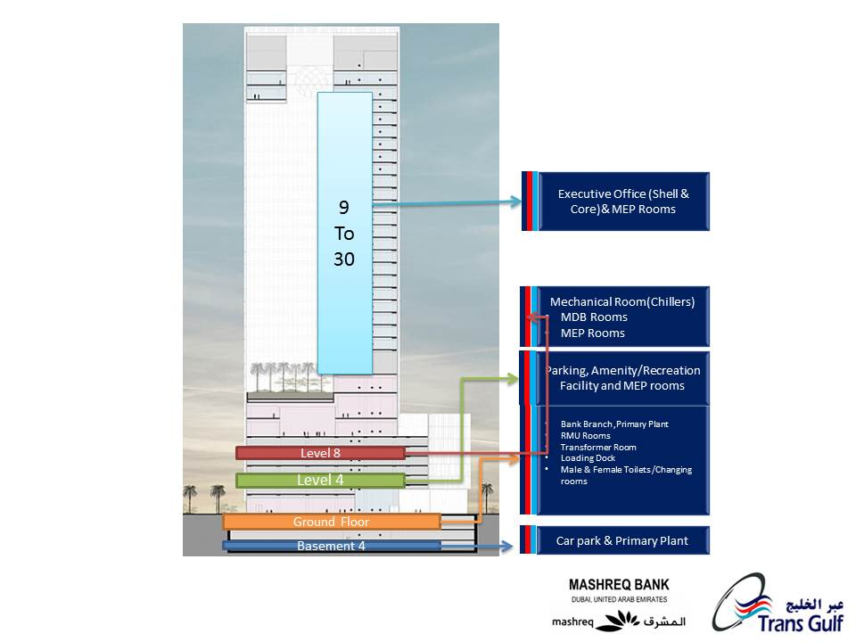

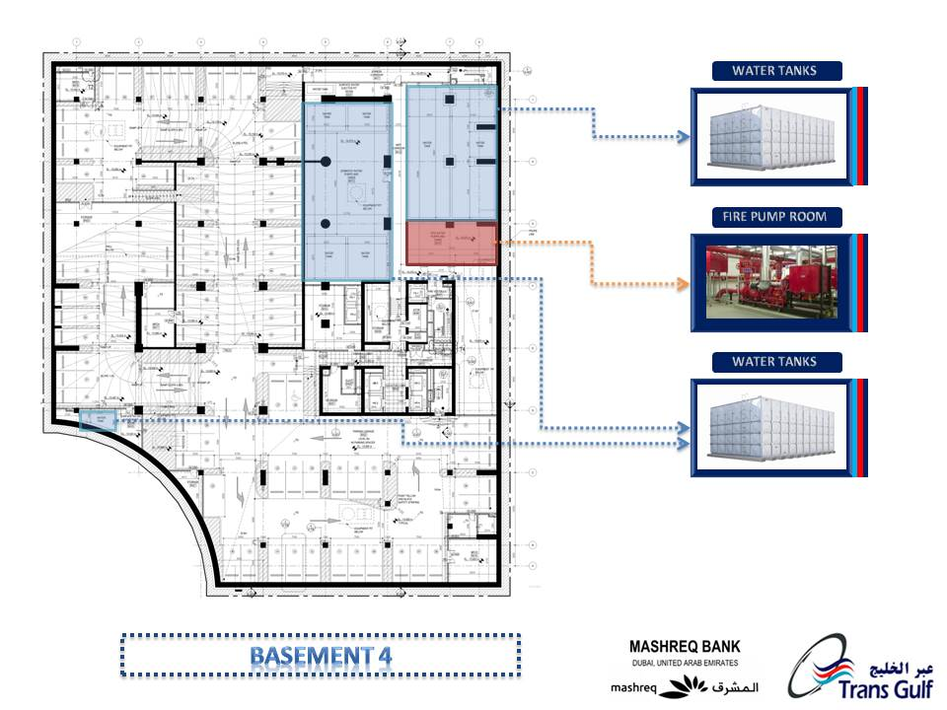

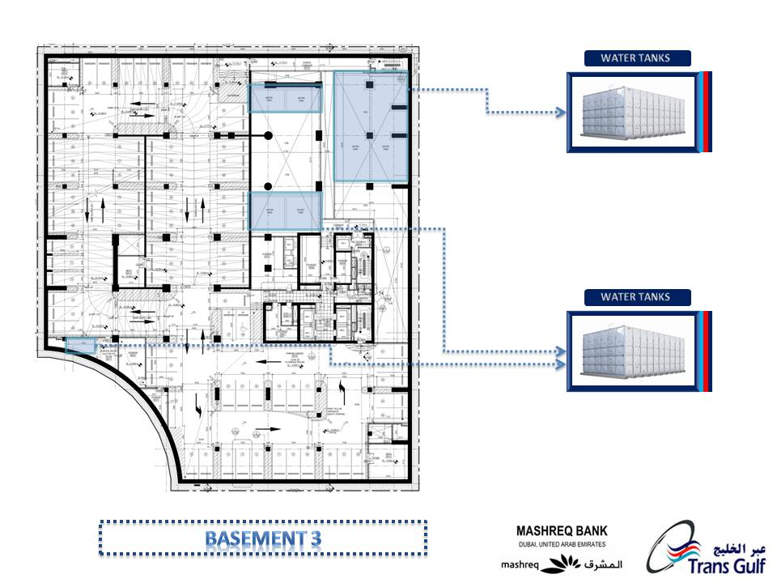

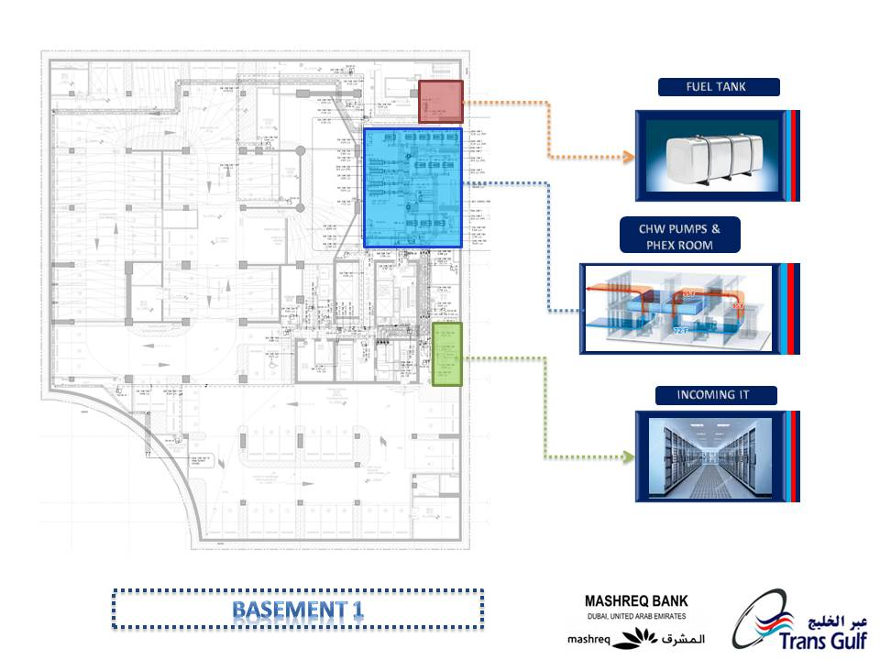

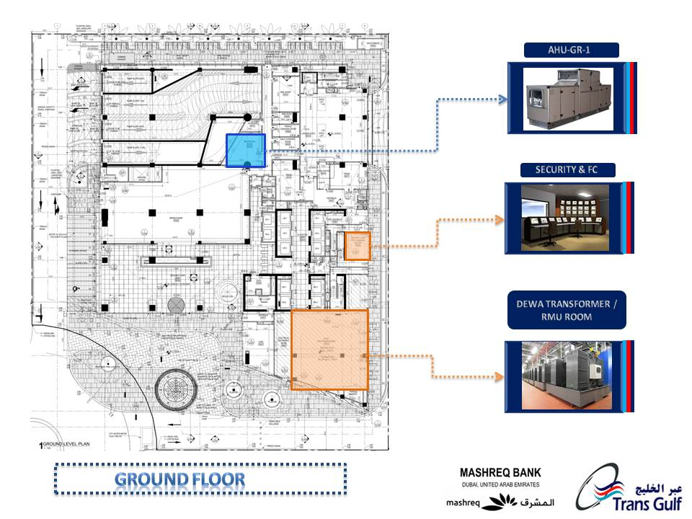

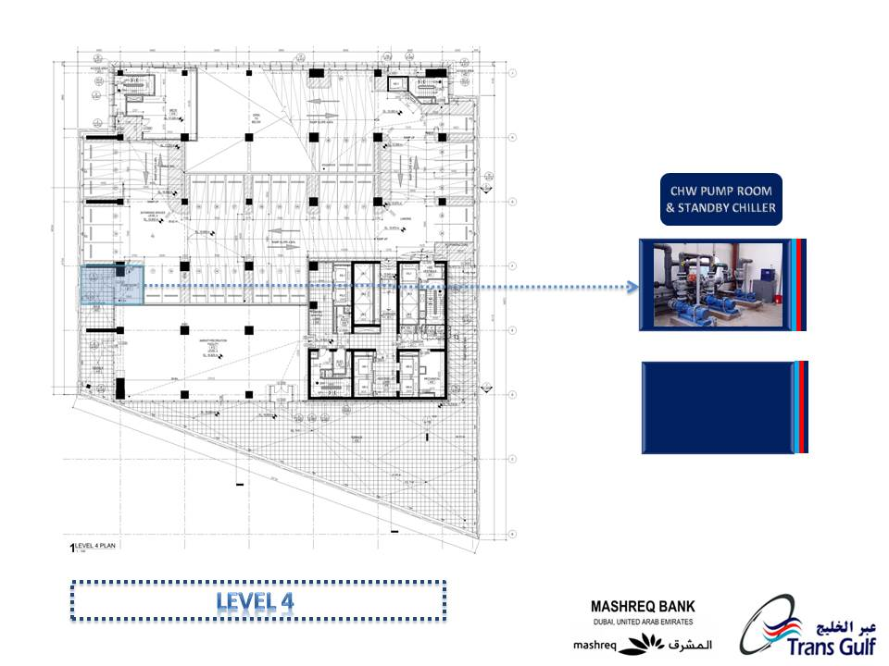

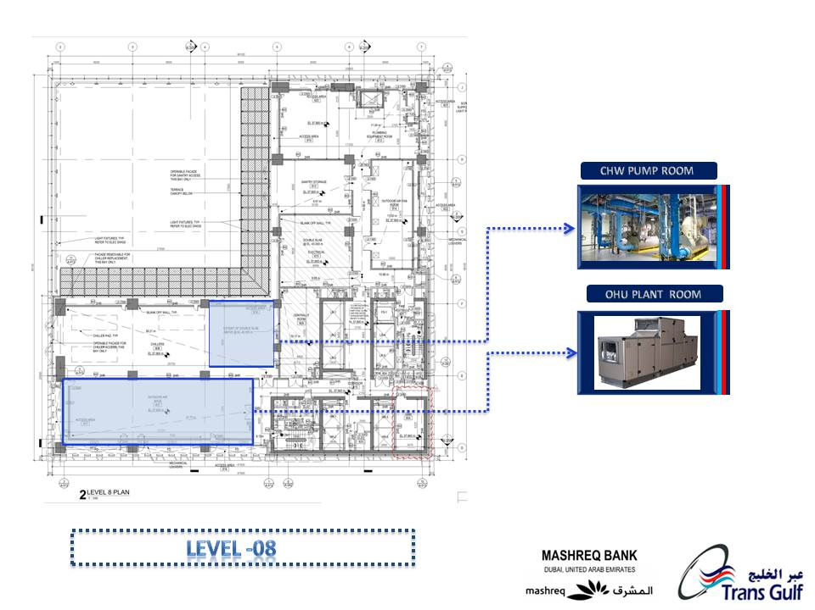

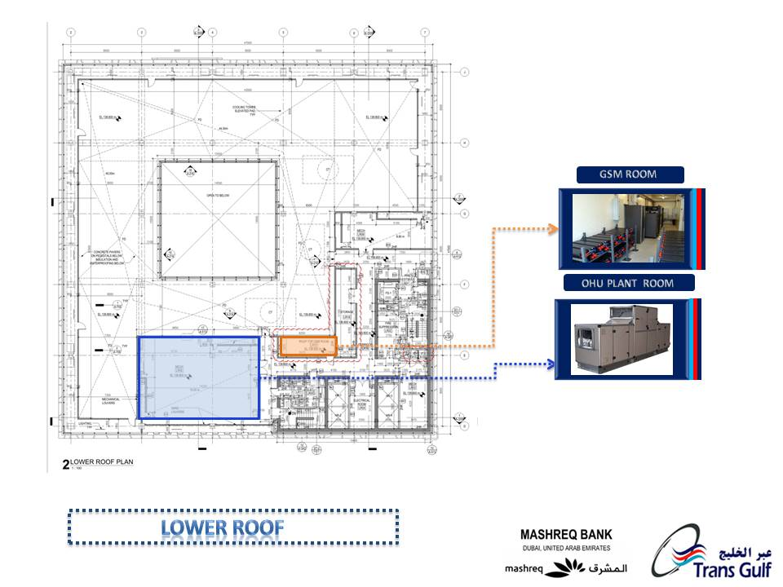

* **MEP Scope of Work**

|  |  |
| --- | --- |
| **HVAC WORKS** | |
| Heat Exchangers |  |
| Fresh Air Handling Units with HRW |  |
| Air Handling Units |  |
| FCUs |  |
| Primary & Secondary Chilled Water Pumps |  |
| Pressurization Units |  |
| PAC Units |  |
| Ventilation Fans |  |
| Air Separator |  |
| Ducting & Insulation |  |
| CHW Piping & Insulation |  |
| Chilled Water Valves |  |
| Air Outlets & Louvers |  |
| VCD’s FD’s & MD’s |  |
| Building Management System (BMS) |  |
| **Electrical Works** | |
| LV Panels (MDBs + EMDBs) & ACB’s |  |
| SMDBs/MCCs |  |
| Capacitor Bank |  |
| DBs |  |
| LV Cables |  |
| Busbar |  |
| Cable Trays and Trunking |  |
| Isolators, Sockets and Switches |  |
| Lighting(Supply and Installation) ; Specialist Lighting (Installation Only) |  |
| Lighting Control System |  |
| Central Battery based Emergency Lighting System |  |
| Fire Alarm with Voice Evacuation system |  |
| Prime Rated Generator |  |
| UPS |  |
| Earthing and Lightning Protection |  |
| Sub – Station Works (By DEWA) |  |
| Transformer (By DEWA) |  |
| ATS |  |
| **ELV Works** | |
| CCTV System |  |
| Structured Cabling System |  |
| Audio Visual System |  |
| Access Control System |  |
| **Plumbing & Fire Fighting Works** | |
| Water Booster Pump (1D+1S) |  |
| Hot Water Circulation Pumpset (1D+1S) |  |
| GRP Water Tank |  |
| Water Heaters |  |
| LPG Fired Water Heater |  |
| SS Cold & Hot Water Piping |  |
| Insulation for Hot Water Piping |  |
| Plumbing Valves |  |
| Fire Fighting System with Piping, Accessories …. Etc. |  |
| Clean gas agent system – Novcc 1230 |  |
| LPG System |  |
| Fuel Oil System |  |

* **Mobilization**

The process of Mobilisation starts upon the receipt of letter of acceptance, which is as follows:

* Confirmation of Letter of acceptance and project kick-off meeting.
* Issuance of IFC’s, Specification’s, Load Schedule’s, NOC’s , etc.,
* Provision of Site offices by Main Contractor.
* Provision of temporary Power and Water for offices & site.
* Mobilisation of Staff and Labour to site as required.
* Client supply Items like Kitchen/ ID/ specialist to be present at site for coordination during preparation of Shop Drawings
* **Overview Programme of works**

Mashreq Bank Project to be completed in a single phase and overall completion time for this project is 31 months, asper Contract. MEP Works including Testing and Commissioning are inline the main contractors programme as shown in the MEP Programme timeline. The project has to be completed within 31 months from date of receipt of Letter of Award, IFC’s, NOC’s, Building Permits and necessary access, which includes the Completion of:

* Engineering
* Procurement
* Installation
* Electrical Energisation
* Testing and Commissioning
* CHW Flushing
* Domestic Water Chlorination
* Authority Inspections & Approvals
* **Programme – Basis & Assumptions**
* Overview: The submitted Program is a high level Program with the intention to achieve Contract Milestones and Time for Completion. Major Durations, Dates and Milestones for Engineering/ Procurement/ Construction/ Commissioning are identified in the programme . Further detailing shall be done upon contract Award.
* Software: The program is made in Primavera P8.2 Project Management software using latest release 8.3.
* Contract Coordination: The Commencement, Time and durations of Subcontract works shall be in co-ordination with Main Contract Programme and sequencing between Contractors or with other Subcontractors shall be specified in the detailed programme made during construction phase. MEP subcontractors shall be followed and coordinated with the main contractor’s detailed look ahead program for daily site works and shall follow the main contractors program which may be issued from time to time by the site planner based on the progress.
* Calendar: All activities in program are following 6 day work week calendar with the exception of few activities like authority inspection which follow 5 day workweek and Procurement/ Flushing i.e. 7 days Calendar. If required night shift permission shall be requested. Holidays for UAE-2016, 2017, 2018 and 2019 shall be applicable.
* Work Breakdown Structure (WBS) : The High level WBS structure is as attached below, detailed WBS shall be submitted during the Construction programme Phase



* **Programme – Overview**
* **Main Critical Path for MEP**
* Civil Structure Complete
* MEP Access to Plant Room/ Riser Level-04
* Major Equipment Installation including Termination (B1, B3, B4, GF, L-01, L-04, L-08, L-11 & Upper Roof)
* Temporary Power/ Water/ Drainage for Wild Air
* Flushing of CHW System
* Equipment Start-up for Wild Air
* Wild Air On
* MEP Final Fixes after Wild Air/ Civil Finishes
* Testing and Commissioning
* Civil Defence Inspection/ Approval
* LPG Inspection / Approval
* DM Inspection/ Approval
* Handing Over
* **Sequence of Construction**

Main Contractor will hand over the site to TG to proceed with following:

* **Access to MEP works:**

As the Mashreq Bank Project has to be completed within 31 months, access to various activities should be provided precisely to avoid any time delay as per the MEP Tender programme submitted along with tender

* **Typical Sequence**
* MEP access after Plaster
* MEP High Level Works
* Embedded Services Wall
* MEP Floor Works (if any)
* Screeds
* MEP Ceiling Grid Clearance
* Ceiling Grids
* MEP Droppers
* Ceiling Works
* Painting/ Marking etc. On Ceiling
* MEP Final Fixes
* Wild Air On
* Finishes
* MEP Final Fixes after Wild Air
* **Testing and Commissioning Installation of Plant Equipment:**
* Plinths for the equipment should be made ready complete with specified finish prior to shifting of equipment as per the programme requirement.
* Al Equipment’s shall be received and unloaded at site directly on to the Plinths to avoid double handling.
* **Flushing of Chilled Water System and Wild Air**
* On completion of major HVAC equipment’s installation and 2nd Fix items, chilled water system will be flushed using temporary power, water and drainage (to be provided by main contractor)
* We have allowed 06 weeks for the flushing
* Once the building is weather proof and clean, with the support of temporary power, water and drainage, equipment’s will be pre-commissioned to provide wild air commencing from 27th Month from MEP Commencement.
* **Testing and Commissioning of Equipment’s in presence of specialist manufacturer representatives including kitchen equipment’s in sequence as below:**
* Electrical switchgear / panels.
* Pumps
* Chillers
* Lighting controls & ELV Systems
* Plumbing systems
* TSE specialist
* LPG System
* Fire Fighting & Fire Suppression System
* Fuel Oil System
* Ventilation and Smoke Fan
* FAHU / AHU
* Testing and Commissioning of certain Mechanical, Electrical, Plumbing, gas and ELV Systems cannot be completed without installation of Kitchen equipment’s and their final termination
* **Main Requirements from Employer/ Main Contractor**
* MEP Award 21-Sep-16
* Release of IFC/ Design NOC/ Final Loads for all Systems 21-Sep-16
* Release of Kitchen Equipment’s final selection 29-Oct-16
* Release of ID Final Details 29-Oct-16
* Building Facade Complete 14-Oct-18
* Undertaking from Engineer / Client to Invite DEWA (Partial Inspection)15-Oct-18
* Temporary Power/ Water/ Drainage for Wild Air 09-Oct-18
* **System Description**
* **Electrical System:**
* RMU Room is Located in Ground floor, comprising of 6 Transformers (Supplied by DEWA) and 4 ACB’s located in ground floor which feed MDB’s (4 nos.) in Level-1. Incoming cable to transformer by DEWA.
* For uninterrupted backup of critical services modular UPS, 3 modular each with 200kva (total 600kva UPS) and 500kva UPS 1 no. back-up time 15 minutes, lead acid battery. UPS to support the IT system located in the building MDF, the technology room / IDF and for the telephony agent / operator to have UPS for their PC’s.
* Essential loads are feeding through 2 nos. of 1500kva prime power rated generator and 14 nos. of ATS panels. Generator units shall be synchronized and paralleled parallelism switchgear and sync controls.
* From Transformer the power is fed to 4 ACB’s which is feeding 4 LV panels located in Level-1 LV Room through Bus bars. From the LV panels the power is distributed to the entire building through various SMDB, MCC`s & DB`s located at various Places. Total 10 nos. of Bus bar risers in which 4 nos. are feeder bus bars (between ACB to MDB – Panel – Level GF to Level -01) and other 6 nos. are riser bus bars feeding from MDB to higher floor levels. Rating of bus bars are 2500A, 2000A, 1600A, 1250A. Non-essential bus bars are 400V TPN & E copper sandwich construction and essential bus bars are fire rated 400V TPN & E copper cast resin type. Also, at level-1 a separate MDB is fed from generator for emergency power. The cable also fed from LV room in the first floor distributed through the riser to basement and to upper floors.
* **Lighting Control System**

1. European Installation Bus Technology (KNX) System.
2. The LCPs shall be surface mounted in IP65 polycarbonate enclosures together with built-in DIN-rails for. Dedicated Lighting Control Panel (LCP) for every DB

* **Fire Alarm System**

1. Analogue Addressable System with Voice Evacuation
2. PAVA Head end scope not clear. Needs Clarification.

* **Central Battery System**

1. AC/DC System, sealed lead acid batteries
2. T5 fluorescent and LED luminaires are proposed. All luminaires used in FOH areas shall be unobtrusive discrete LED types

* **Structured Cabling including Active Components**

(a) CAT 6A Cabling

(b) Network switches, Fire walls, IP Telephony System and containment for GSM

System

* **Audio Visual System**

AV System requirement in Lobby, Auditorium / Pre- function Area, Cafeteria.

* + **Earthing & Lightning Protection**

Sealed Earth Pit, Solid Copper rod. Pile Earthing for Lightning Protection System. Structural Re-bar to be used as Down conductor

* **CCTV System**
* **Access Control System including Gate Barrier**
* **Intercom System**
* **Wiring Devices & Isolators**

Arteor neutral white, with screw less faceplates for ID Areas, White plastic for BOH areas External isolators IP65 with Die cast aluminium and Internal Isolators IP54 or IP65 with Polycarbonate housing.

* **Light Fittings**

1. Supply, installation of Internal and External Light Fittings.
2. Façade and Landscaping part of Specialist Lighting Package.

* **Aircraft Warning Lights**

1. 4 nos. of Medium Intensity Aircraft Warning Light, dual Flush heads with photo control of daytime and night time intensities
2. The system will be white flashing daytime and red flashing night time.

* **HVAC System :**
* The cooling for Mashreq Bank Headquarters Building is provided by chilled water supplies from the district cooling provider (Emaar District Cooling L.L.C).
* Tap off connections for 1,700 TR are taken from District cooling system and further supplied connected to HEX installed at basement 1, The Chilled water pumps are located at the Basement-1 which are serving the chilled water to entire building.
* Two separate chilled water loops are serving to the tower building, (a) chilled water low riser system (PN 16 pressure rated), (b) chilled water high riser system (PN 25 pressure rated).
* In the event of power failure cooling to areas such as the elevator M/C room, Central IT room, UPS room, satellite service equipment rom and the telecommunication service entrance room is maintained through Air cooled package chiller located at 4 level with dedicated piping network.
* From Level -9 to level-31, open offices, provided with Temporary Fan coil unit without Ductwork and its accessories & Capped off Provision given for Tenant FCU Connection.
* AHU’s are located in ground, first, level 4 & basement 3 parking. FAHU’s are located in the 8th floor and lower roof serving the fresh air requirement for the tower.
* Ducted mechanical ventilation system is provided for the Basement car park ventilation (normal & 5 no. operation).
* Stair & Lift well are serving with pressurization system fans.
* Corridor & Office having with Smoke Extract System.
* Kitchen extract systems serving Level 6 & 7 kitchen are with Ecology System.
* **BMS System**

The BMS system shall be used to control and monitor the functions of the building MEP systems, plant and equipment.

* **Plumbing Scope**
* Drainage is currently not part of TG’s scope of works

* **Water Supply**
  + Potable water services will be provided by a DEWA incoming cold water supply. The supply shall enter the Building at Basement Level B1 high level and serve 2 nos. of potable water storage tanks. To maintain water quality, a copper silver ionization unit shall be provided. The cold water shall pass through a variable speed cold water booster set and distribute to serve all the appliances within the building.
  + Supply to tenant at ground floor will be metered by DEWA. The tenants plumbing system shall terminate with an isolating valve and pressure reducing valve and shall be capped for continuation by tenants.
  + All water supply pipework shall be in stainless steel and pipework concealed in the wall shall be PEX.
  + Hot water shall be supplied using instantaneous point-of-use electric water heaters for the 27, 28, 29, 30 & 31 floors & direct LPG fired water heaters located in level-8 feeding kitchens.
* **Fire Fighting System**
  + The dedicated fire water storage tanks are located on Basement 4 & Level 11 to serve both the low zone and high zone areas of the building Wet Pipe Sprinkler Systems
  + The fire water contained in the dedicated fire water storage tank shall supply water for all the wet based systems (i.e. fire sprinkler, standpipe and hydrant) for Mashreq Bank Headquarters Tower building.
  + Dedicated fire pump sets shall serve the Mashreq Bank Headquarters Tower building, two (2) sets located in the fire pump room on Basement Level B4 supplying the sprinkler / standpipe (for the Low Zone areas) and hydrant systems. The other fire pump set is located in Level 11 that serves the sprinkler / standpipe systems for the High Zone areas.
  + Electrical, Incoming IT, Emergency Switch Gear, Central IT Room shall be served by Clean Agent Gaseous Fire Suppression Systems (Novec-1230)
  + Generator Room shall be served by Foam Water Systems
* **Irrigation System –** 
  + Irrigation (TSE) water to be supplied directly from the Main External Network to the irrigation tank located at the basement level. Internal planter areas to be irrigated with Irrigation water supply by Irrigation specialist.
* **Gas System** 
  + Connection to local LPG Network
  + LPG distribution system -Tap off from network & supply in tenant area.
  + LPG is using for the gas fired water heater.
* **Fuel Oil System**

Fuel oil tanks along with fuel pump set are located in basement # 1 fuel tank room which is feeding fuel oil to the generator (emergency) located in level # 1. Fuel filling box is provided in the ground floor for filling fuel oil to the fuel tank from the external source.

* **Project execution**
* **Procedures and Sequencing:**
* All procedures and sequencing will be based on good engineering practices and approved quality procedures.
* Sequence of installation / activities will be based on agreed programme and access to various areas.
* **Engineering:**

Transgulf will implement BIM to provide industry leading Co-ordination and Integration of Services. Our BIM team will work in close co-ordination with design team and Main Contractor to develop integrated building models.

Trans Gulf has taken following approach towards Engineering.

* Preparation of Shop Drawings in compliance with Contract Requirements using BIM.
* Selection of Equipment in compliance with Contract Requirements, taking consideration of approval, procurement and delivery periods.
* Submission of Drawings, Equipment & Material for Consultants Approval.
* Co-ordination with Specialist Equipment suppliers
* Identify & resolve special constraints in co-ordination with design team and Main Contractor.
* Carry out design verification calculations on selected equipment.
* Identify opportunities to Rationalise & Value Engineering Design.
* Technical reviews and selection of Manufacturers & Products.
* **Procurement**

Our centralised Procurement Team based at our Dubai head office will liaise closely with the project team to provide efficient procurement support.

* Prepare material procurement schedule in accordance with the Construction Programme.
* Follow up with Vendors and manufacturers for On-Time deliveries & manufacturing updates.
* Float enquiries to specified Vendors with capability and track record to deliver projects of this size & nature
* Secure delivery commitment as per project requirements.
* Co-ordinate with Logistic department for follow-up, receipt, clearance and site delivery
* **Logistics**

Logistics will be a key factor in the successful delivery of this project, requiring detailed co-ordination between procurement, planning & construction departments.

Upon Contract Award Trans Gulf will develop a detailed logistics can comprising the following:-

* Site stores set-up
* Equipment schedule indicating equipment locations, sizes & weights
* Specific lighting requirements
* Major equipment delivery dates
* Anticipated monthly material quantities (pipe, tray, duct etc.)
* Anticipated power and water requirements (location and consumption)
* Riser works
* Scaffolding requirements
* Equipment movement plan – access routes for installation of permanent equipment
* Lifting/ Crainage will be co-ordinated and to be arranged by the Main Contractor. MEP Subcontractor will co-ordinate with the Main Contractor for the same to ensure that the facilities are available in a timely manner.
* Major Equipment’s are located at Basement 01, Basement 3, Basement 4, GF, Level 01, Level 04, Level 5, Level 08, Level 11, Level 24, Level 25 and Lower roof (Provisions to be made for Equipment Logistics including loading platform by others. MEP Equipment details will be provided by MEP subcontractor)
* Wherever the floor height is 6 meters, to install MEP services continuous platform/decking/ high level scaffolding is required and the same shall be co-ordinated with Main Contractor
* Planned delivery as per Contract programme / site requirement.
* Safety Clearance for Hoists, Scaffoldings and Access platforms
* **Co ordination**

One of the Key elements for this project is proactive approach to resolve the perceived intricacies and conflicts between internal disciplines as well as other package contractors

* Co-ordination will be key element for the following
* Engineering
* Installation and Access for installation
* Interfaces with external network services (Chilled water, TSE, LPG).
* Movement of Men & Material
* Statutory Authorities
* **Installation**
* Particular/specific method statement of installation of various items/equipment’s/system will be submitted along with Risk assessment prior to start of work (samples attached)
* Acceptance to access in areas as offered by Civil Contractor for MEP Works.
* Permit to work methodology will be followed in close coordination with Civil Contractor for works like hot water, high level works and confined space works along with the Risk mitigation option.
* Sequence of activities will be followed as per Agreed programme with the Civil Contractor.
* Services will be installed in co-ordination with other services like, structural and Architectural elements.
* Inspection and obtaining approvals at key holding points.
* Area hand over to Civil Contractor for further activities.
* **Authority approval**

Trans Gulf will liaise with Authorities well in advance for approvals and NOC’s to get power and water prior to Commissioning.

* Substation Inspection/ handover to DEWA
* Interaction with DEWA for Site Inspection of Installation to release temporary release of Permanent Power.
* DEWA release of Water.
* Civil Defence Inspection and Approvals.
* Inspection by DM and Approval.
* Submission of Civil Defence and DM approvals to DEWA.
* Building Occupancy approval from DM
* DEWA release of Permanent Power.
* Dubai Police Inspection and Approval
* Etisalat / DU Inspection and Approval
* **Commissioning**
* Overall Testing & Commissioning Management plan will be prepared for the project.
* We have allowed 4 months of Commissioning Duration. The Commissioning will commence based on the Temporary Power/ Water etc., to be provided by Main Contractor free to Subcontractor as indicated in the Programme, till the time DEWA Power is available.
* Dedicated Commissioning team would be in place to liaise closely with the Construction Team to incorporate the Commissioning requirements, at the time of system installation.
* The Commissioning of the free issue item (Sanitaryware) to be carried out in close coordination with supplier/ Manufacturer.
* Tests will be done on each equipment as per the specification / contract requirement to measure the performance.
* **Closeout & Hand over**
* Closing of NCRs & Site Observations
* Snagging & De snagging
* As built drawings preparation and submission
* Preparation and Submission of Testing & Commissioning reports
* Preparation and Submission of O & M manual.
* Clients Staff Training.
* Preparation and Submission of Spare Parts list
* TOC Application
* Warranties
* Application for retention release
* Conversion of Temp power to Permanent Power from DEWA.
* Demobilisation of staff
* Handing over of documents
* Issuance of TOC by Employer.
* Start of DLP as per Contract.

------------------x------------------